**Phase-3 Practice Project: Assisted Practice -**

# 1. Set up a Spring framework environment

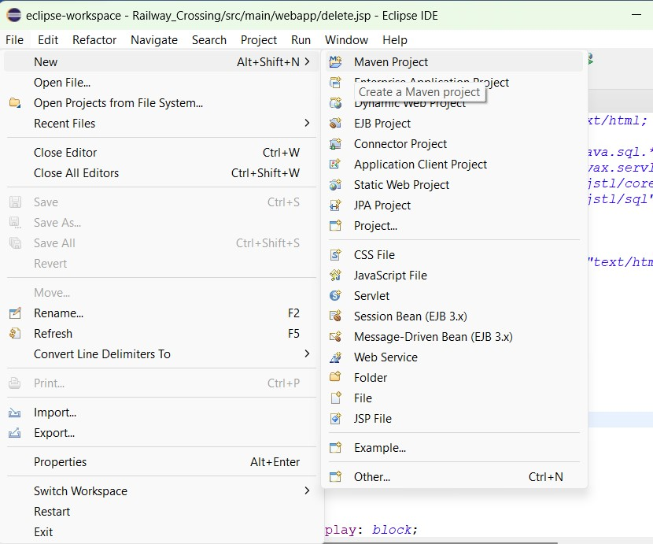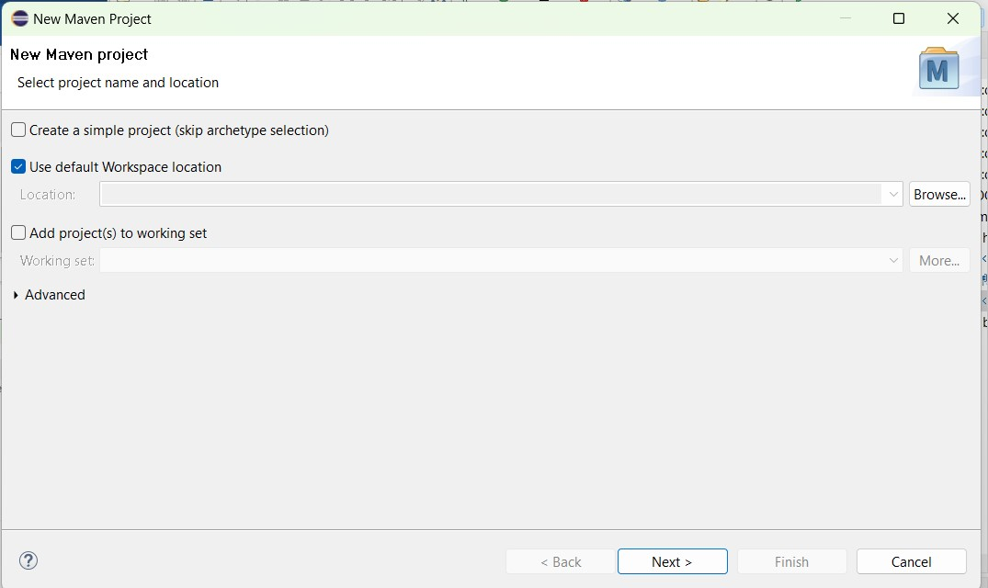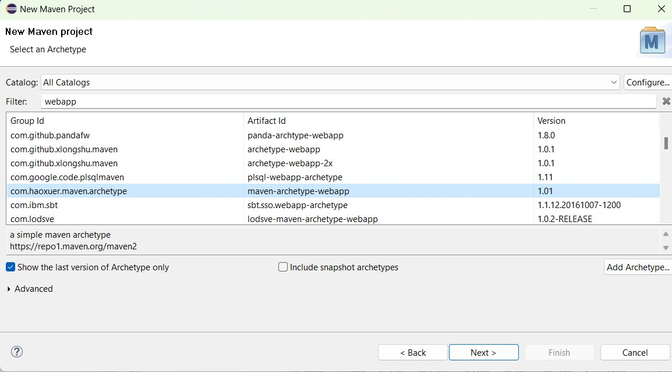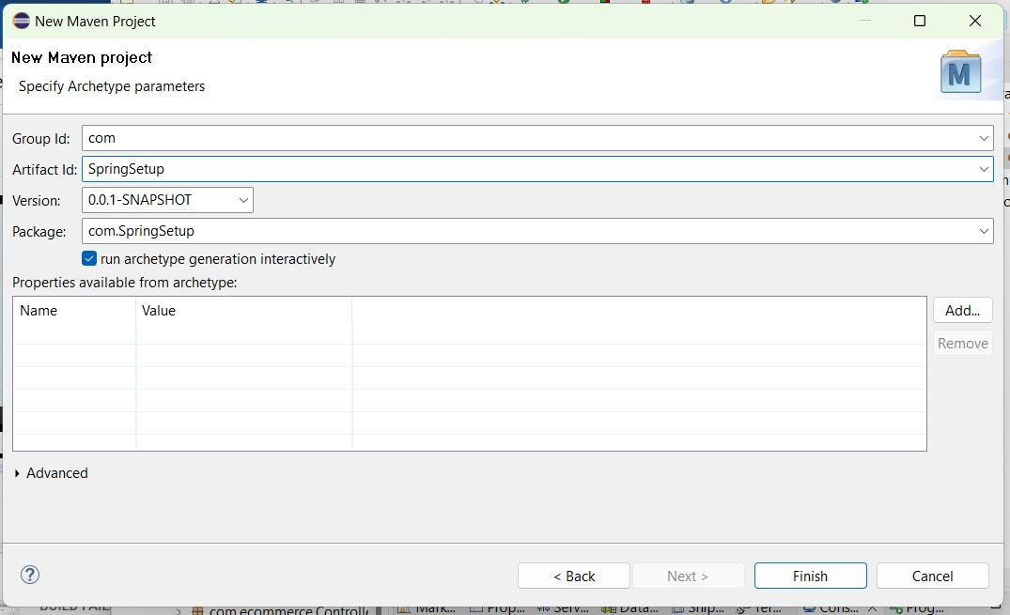

**Source Code:**

# POM.XML

<?xml version="1.0" encoding="UTF-8"?>

<projectxmlns="http://maven.apache.org/POM/4.0.0"xmlns:xsi="http://www.w3.org/2001/XMLSchema-instance"xsi:schemaLocation="http://maven.apache.org/POM/4.0.0 [http://maven.apache.org/xsd/maven-4.0.0.xsd"](http://maven.apache.org/xsd/maven-4.0.0.xsd)>

<modelVersion>4.0.0</modelVersion>

<groupId>com</groupId>

<artifactId>SpringSetup</artifactId>

<version>0.0.1-SNAPSHOT</version>

<packaging>war</packaging>

<name>SpringSetup Maven Webapp</name>

<!-- FIXME change it to the project's website -->

<url>http://www.example.com</url>

<properties>

<org.springframework.version>6.0.4</org.springframework.version>

<maven.compiler.source>1.8</maven.compiler.source>

<maven.compiler.target>1.8</maven.compiler.target>

</properties>

<dependencies>

<dependency>

<groupId>junit</groupId>

<artifactId>junit</artifactId>

<version>3.8.1</version>

<scope>test</scope>

</dependency>

<dependency>

<groupId>org.springframework</groupId>

<artifactId>spring-core</artifactId>

<version>${org.springframework.version}</version>

</dependency>

<dependency>

<groupId>org.springframework</groupId>

<artifactId>spring-expression</artifactId>

<version>${org.springframework.version}</version>

</dependency>

<dependency>

<groupId>org.springframework</groupId>

<artifactId>spring-beans</artifactId>

<version>${org.springframework.version}</version>

</dependency>

<dependency>

<groupId>org.springframework</groupId>

<artifactId>spring-context</artifactId>

<version>${org.springframework.version}</version>

</dependency>

<dependency>

<groupId>org.springframework</groupId>

<artifactId>spring-context-support</artifactId>

<version>${org.springframework.version}</version>

</dependency>

<dependency>

<groupId>org.springframework</groupId>

<artifactId>spring-jdbc</artifactId>

<version>${org.springframework.version}</version>

</dependency>

<dependency>

<groupId>org.springframework</groupId>

<artifactId>spring-orm</artifactId>

<version>${org.springframework.version}</version>

</dependency>

<dependency>

<groupId>org.springframework</groupId><artifactId>spring-web</artifactId>

<version>${org.springframework.version}</version>

</dependency>

<dependency>

<groupId>org.springframework</groupId>

<artifactId>spring-webmvc</artifactId>

<version>${org.springframework.version}</version>

</dependency>

<dependency>

<groupId>javassist</groupId>

<artifactId>javassist</artifactId>

<version>3.12.1.GA</version>

</dependency>

<dependency>

<groupId>taglibs</groupId>

<artifactId>standard</artifactId>

<version>1.1.2</version>

<scope>runtime</scope>

</dependency>

<dependency>

<groupId>commons-dbcp</groupId>

<artifactId>commons-dbcp</artifactId>

<version>1.4</version>

</dependency>

<!--[https://mvnrepository.com/artifact/jakarta.servlet.jsp/jakarta.servlet.jsp-](https://mvnrepository.com/artifact/jakarta.servlet.jsp/jakarta.servlet.jsp-api)

[ap](https://mvnrepository.com/artifact/jakarta.servlet.jsp/jakarta.servlet.jsp-api)

[i](https://mvnrepository.com/artifact/jakarta.servlet.jsp/jakarta.servlet.jsp-api)

--

>

<!--<dependency>

<groupId>jakarta.servlet</groupId>

<artifactId>jakarta.servlet-api</artifactId>

<version>6.0.0</version>

</dependency>-->

<!--<https://mvnrepository.com/artifact/javax.servlet/javax.servlet-api>-->

<dependency>

<groupId>javax.servlet</groupId>

<artifactId>javax.servlet-api</artifactId>

<version>3.0.1</version>

<scope>provided</scope>

</dependency>

<!--[https://mvnrepository.com/artifact/jakarta.servlet.jsp.jstl/jakarta.servlet](https://mvnrepository.com/artifact/jakarta.servlet.jsp.jstl/jakarta.servlet.jsp.jstl-api)

[.jsp.jstl-api](https://mvnrepository.com/artifact/jakarta.servlet.jsp.jstl/jakarta.servlet.jsp.jstl-api)-->

<dependency>

<groupId>jakarta.servlet.jsp.jstl</groupId>

<artifactId>jakarta.servlet.jsp.jstl-api</artifactId>

<version>3.0.0</version>

</dependency>

<dependency>

<groupId>mysql</groupId>

<artifactId>mysql-connector-java</artifactId>

<version>8.0.32</version>

</dependency>

<dependency>

<groupId>javax.persistence</groupId><artifactId>persistence-api</artifactId>

<version>1.0.2</version>

<scope>provided</scope>

</dependency>

<dependency>

<groupId>junit</groupId>

<artifactId>junit</artifactId>

<version>4.11</version>

<scope>test</scope>

</dependency>

</dependencies>

<build>

<finalName>SpringSetup</finalName>

<pluginManagement><!-- lock down plugins versions to avoid using Maven defaults (may be moved to parent pom) -->

<plugins>

<plugin>

<artifactId>maven-clean-plugin</artifactId>

<version>3.1.0</version>

</plugin>

<!-- see [http://maven.apache.org/ref/current/maven-core/defaultbindings.html#Plugin_bindings_for_war_packaging](http://maven.apache.org/ref/current/maven-core/default-bindings.html#Plugin_bindings_for_war_packaging)-->

<plugin>

<artifactId>maven-resources-plugin</artifactId>

<version>3.0.2</version>

</plugin>

<plugin>

<artifactId>maven-compiler-plugin</artifactId>

<version>3.8.0</version>

</plugin>

<plugin>

<artifactId>maven-surefire-plugin</artifactId>

<version>2.22.1</version>

</plugin>

<plugin>

<artifactId>maven-war-plugin</artifactId>

<version>3.2.2</version>

</plugin>

<plugin>

<artifactId>maven-install-plugin</artifactId>

<version>2.5.2</version>

</plugin>

<plugin>

<artifactId>maven-deploy-plugin</artifactId>

<version>2.8.2</version>

</plugin>

</plugins>

</pluginManagement>

</build>

</project>